Reviewed by Emil Memon
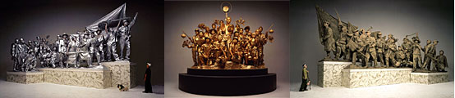

Wang Qingsong, “Past, Present, Future,” 2001
digital c-print (triptych)
In the last few years, Chinese art has been slowly introduced by a group of its dedicated champions to the West, and especially to the New York contemporary art world. As with other so called new markets, a group of westerners, in this case cultural entrepreneurs descended into the new territory and carefully selected and guided a group of talented young Chinese artists who emerged as the first generation after the Tianamen square massacre. Several generations are trying to transcend or ignore the political past, and with the rest of the Chinese economy to catch up on western technology — in this case cultural technology.
There are some similarities in style and sensibility with artists from other post dictatorial societies that recently opened up (like so called Eastern Europe or South America). There is a difference since Chinese society underwent a successful, rapid economic modernization and hard core economic capitalism—but not political pluralism—and actually so called “communism” is guaranteeing its economic success. This condensed, short time frame of changes and contradictions gives the show its unique quality, and the result is one of hard-edged beauty.
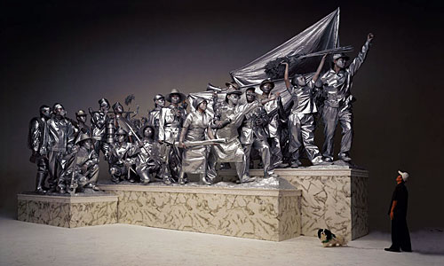
Owing to the erudite knowledge by a specialized, small circle of academics, art critics, curators, art dealers and collectors, Chinese contemporary art exploded with a bang in a series of well timed and organized exhibitions and publications, into the consciousness of the large mainstream art world. Chinese contemporary art arrived into the warm embrace of the contemporary art market, mirroring China’s spectacular success in the world economic markets. There were previous large presentations of Chinese contemporary art, notably the exhibition in 1999 at Asia Society and P.S.1, however, this exhibition joins fresh new faces with what are now almost classic works of Chinese contemporary art. There emerges a strong group of artists who are self-assured and well equipped with knowledge of the global media and whose work goes beyond the hackneyed east vs west dichotomy.
There is a stellar photographic work at ICP by Wang Qingsong that impresses the viewer with its large scale imagery and panoramic format. Updating a famous Tang dynasty painting “Night Revels of Laoli”, the artist stages replaces the original court figures with important figures in contemporary art scene in China (the art critic Li Xianting) and himself into a grand court scene—his version of the Warhol factory. Equally striking is his work at the Asia Society, where with the triptych “Past, Present, Future” he stages his figures into a tableaux vivante referencing imagery of Chinese social realism of the not so far past. Heroically-posed figures in mud, silver and gold are representing different phases of China. He is using staging almost as a Baroque painter would do, so it is not surprising that he moved with his latest body of work, also presented at this time in NYC, to the western art historical themes.
Another powerful work is that of Zhang Huan, whose photograph incorporate reference to body art of Chris Burden or Vito Acconci but in the much more squalid environment of a public toilet with honey and flies over his body. He endures the pain that we can sense with Zen-like patience.
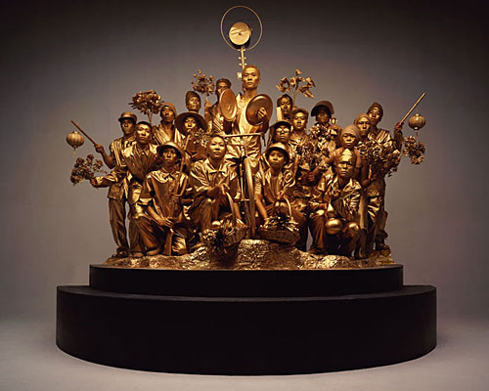
Zhao Bandi with his Panda are also present at this show. His sidekick is a toy panda representing China. His work is such that you must have knowledge of Chinese cultural, social and physical landscape. His work is a simple, gentle, charming social parody but graced with extraordinary beauty. The example in the show is good, but he works better in accumulation (as a series of photos), because he and his Panda grow on you..
In an old-school type of conceptual work, like something from the 70’s, the Beijing based artist Song Dong is stamping water with a stamp that says water. It is a beautiful gesture, and makes you nostalgic for simpler and pure times. The fact that is a series of photographs on the wall, documenting the performance makes this impression stronger.
There is a lot to see in the exhibition (for instance, the powerful work of Qui Zhijie), and there are plenty of other works and many other artists that will catch your attention. This is not only an exhibition for people with a special interest in China, but for everyone that likes good art.
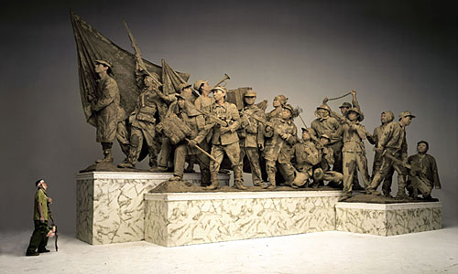
“Between Past and Future: New Photography and Video from China” is Curated by Wu Hung and Christopher Phillips. It is the first comprehensive look at the innovative photo and video art produced since the mid-1990s in China, and will be presented jointly at the International Center of Photography and the Asia Society and Museum from June 11 to September 5, 2004.
This traveling exhibition continues on to the Smart Museum of Art, University of Chicago, and Museum of Contemporary Art, Chicago (Oct. 2, 2004-Jan. 16, 2005), Seattle Art Museum (Feb. 10-May 15, 2005), Haus der Kulturen der Welt, Berlin (March-May, 2006), Santa Barbara Museum of Art (Summer 2006)
New York, August 2004

